Table 5 Statistical metrics results for hybrid SVR models

 |  | SVR-CMAES |  |  |  | SVR-GSA
 |  | C1 | C2 | C3 | C4 | C1 | C2 | C3 | C4
Alor Setar | MAE | 0.387 | 0.114 | 0.083 | 0.039 | 0.387 | 0.114 | 0.065 | 0.031
 | RMSE | 0.507 | 0.178 | 0.122 | 0.050 | 0.506 | 0.178 | 0.089 | 0.042
 | R² | 0.759 | 0.970 | 0.985 | 0.997 | 0.759 | 0.970 | 0.993 | 0.998
 | d1 | 0.930 | 0.992 | 0.996 | 0.999 | 0.930 | 0.992 | 0.998 | 0.999
 | KGE | 0.836 | 0.977 | 0.988 | 0.997 | 0.836 | 0.978 | 0.993 | 0.998
 | GPI | 0.953 | 0.995 | 0.996 | 0.999 | 0.953 | 0.996 | 0.997 | 0.999
 |  | Excel | Excel | Excel | Excel | Excel | Excel | Excel | Excel
Pulau Langkawi | MAE | 0.446 | 0.157 | 0.090 | 0.04 | 0.446 | 0.182 | 0.085 | 0.040
 | RMSE | 0.569 | 0.249 | 0.130 | 0.05 | 0.566 | 0.271 | 0.123 | 0.050
 | R² | 0.734 | 0.949 | 0.986 | 1.00 | 0.736 | 0.940 | 0.988 | 0.998
 | d1 | 0.921 | 0.971 | 0.996 | 0.999 | 0.921 | 0.984 | 0.996 | 0.997
 | KGE | 0.821 | 0.954 | 0.989 | 0.994 | 0.819 | 0.960 | 0.991 | 0.994
 | GPI | 0.946 | 0.969 | 0.998 | 0.999 | 0.948 | 0.989 | 0.998 | 0.999
 |  | Excel | Excel | Excel | Excel | Excel | Excel | Excel | Excel
Bayan Lepas | MAE | 0.567 | 0.171 | 0.114 | 0.038 | 0.495 | 0.167 | 0.096 | 0.032
 | RMSE | 0.72 | 0.283 | 0.166 | 0.049 | 0.627 | 0.282 | 0.136 | 0.043
 | R² | 0.529 | 0.928 | 0.975 | 0.997 | 0.646 | 0.928 | 0.983 | 0.998
 | d1 | 0.822 | 0.981 | 0.993 | 0.999 | 0.884 | 0.981 | 0.995 | 0.996
 | KGE | 0.604 | 0.939 | 0.976 | 0.994 | 0.733 | 0.939 | 0.984 | 0.994
 | GPI | 0.604 | 0.993 | 0.994 | 0.996 | 0.938 | 0.994 | 0.997 | 0.999
 |  | Bear | Excel | Excel | Excel | Excel | Excel | Excel | Excel
Ipoh | MAE | 0.316 | 0.070 | 0.045 | 0.026 | 0.303 | 0.070 | 0.043 | 0.026
 | RMSE | 0.397 | 0.099 | 0.061 | 0.037 | 0.384 | 0.099 | 0.057 | 0.034
 | R² | 0.733 | 0.983 | 0.993 | 0.997 | 0.749 | 0.983 | 0.994 | 0.998
 | d1 | 0.919 | 0.957 | 0.984 | 0.995 | 0.925 | 0.985 | 0.998 | 0.999
 | KGE | 0.806 | 0.985 | 0.933 | 0.992 | 0.821 | 0.985 | 0.993 | 0.999
 | GPI | 0.953 | 0.981 | 0.982 | 0.999 | 0.955 | 0.987 | 0.993 | 0.999
 |  | Excel | Excel | Excel | Excel | Excel | Excel | Excel | Excel
Lubok Merbau | MAE | 0.433 | 0.054 | 0.039 | 0.026 | 0.320 | 0.053 | 0.039 | 0.026
 | RMSE | 0.615 | 0.087 | 0.056 | 0.035 | 0.417 | 0.085 | 0.052 | 0.034
 | R² | 0.504 | 0.990 | 0.996 | 0.998 | 0.789 | 0.991 | 0.997 | 0.998
 | d1 | 0.857 | 0.995 | 0.998 | 0.999 | 0.938 | 0.993 | 0.995 | 0.999
 | KGE | 0.711 | 0.994 | 0.996 | 0.998 | 0.844 | 0.994 | 0.995 | 0.996
 | GPI | 0.990 | 0.992 | 0.997 | 0.999 | 0.966 | 0.993 | 0.998 | 0.999
 |  | Excel | Excel | Excel | Excel | Excel | Excel | Excel | Excel
Sitiawan | MAE | 0.397 | 0.055 | 0.034 | 0.023 | 0.329 | 0.054 | 0.033 | 0.024
 | RMSE | 0.496 | 0.071 | 0.044 | 0.031 | 0.424 | 0.068 | 0.044 | 0.031
 | R² | 0.609 | 0.991 | 0.997 | 0.998 | 0.713 | 0.992 | 0.996 | 0.998
 | d1 | 0.887 | 0.995 | 0.996 | 0.999 | 0.912 | 0.993 | 0.997 | 0.999
 | KGE | 0.788 | 0.994 | 0.996 | 0.997 | 0.789 | 0.992 | 0.997 | 0.998
 | GPI | 0.985 | 0.993 | 0.998 | 0.999 | 0.950 | 0.993 | 0.997 | 0.999
 |  | Excel | Excel | Excel | Excel | Excel | Excel | Excel | Excel
Cameron Highlands | MAE | 0.426 | 0.046 | 0.043 | 0.033 | 0.408 | 0.046 | 0.041 | 0.025
 | RMSE | 0.584 | 0.069 | 0.059 | 0.042 | 0.557 | 0.067 | 0.055 | 0.034
 | R² | 0.647 | 0.995 | 0.996 | 0.998 | 0.679 | 0.995 | 0.996 | 0.999
 | d1 | 0.899 | 0.997 | 0.998 | 0.999 | 0.905 | 0.996 | 0.998 | 0.999
 | KGE | 0.803 | 0.994 | 0.995 | 0.999 | 0.794 | 0.995 | 0.997 | 0.998
 | GPI | 0.898 | 0.995 | 0.998 | 0.999 | 0.924 | 0.995 | 0.998 | 0.999
 |  | Excel | Excel | Excel | Excel | Excel | Excel | Excel | Excel
Kuantan | MAE | 0.433 | 0.071 | 0.053 | 0.031 | 0.397 | 0.072 | 0.049 | 0.031
 | RMSE | 0.579 | 0.093 | 0.072 | 0.040 | 0.536 | 0.093 | 0.064 | 0.040
 | R² | 0.635 | 0.990 | 0.994 | 0.998 | 0.686 | 0.990 | 0.995 | 0.996
 | d1 | 0.887 | 0.991 | 0.993 | 0.997 | 0.906 | 0.991 | 0.993 | 0.998
 | KGE | 0.754 | 0.989 | 0.996 | 0.998 | 0.796 | 0.989 | 0.993 | 0.996
 | GPI | 0.917 | 0.992 | 0.997 | 0.999 | 0.928 | 0.992 | 0.995 | 0.999
 |  | Excel | Excel | Excel | Excel | Excel | Excel | Excel | Excel
Muadzam Shah | MAE | 0.348 | 0.053 | 0.032 | 0.030 | 0.349 | 0.049 | 0.032 | 0.030
 | RMSE | 0.461 | 0.069 | 0.044 | 0.041 | 0.459 | 0.066 | 0.044 | 0.042
 | R² | 0.741 | 0.991 | 0.997 | 0.998 | 0.743 | 0.991 | 0.995 | 0.997
 | d1 | 0.923 | 0.990 | 0.994 | 0.995 | 0.923 | 0.989 | 0.995 | 0.996
 | KGE | 0.819 | 0.990 | 0.992 | 0.993 | 0.815 | 0.990 | 0.995 | 0.995
 | GPI | 0.951 | 0.991 | 0.995 | 0.999 | 0.954 | 0.990 | 0.994 | 0.996
 |  | Excel | Excel | Excel | Excel | Excel | Excel | Excel | Excel
Kota Bharu | MAE | 0.383 | 0.122 | 0.108 | 0.046 | 0.486 | 0.122 | 0.083 | 0.051
 | RMSE | 0.495 | 0.209 | 0.122 | 0.094 | 0.639 | 0.187 | 0.135 | 0.096
 | R² | 0.742 | 0.970 | 0.974 | 0.993 | 0.721 | 0.975 | 0.987 | 0.993
 | d1 | 0.936 | 0.993 | 0.994 | 0.992 | 0.919 | 0.938 | 0.995 | 0.996
 | KGE | 0.825 | 0.981 | 0.982 | 0.996 | 0.809 | 0.984 | 0.990 | 0.994
 | GPI | 0.937 | 0.990 | 0.992 | 0.998 | 0.934 | 0.993 | 0.995 | 0.999
 |  | Excel | Excel | Excel | Excel | Excel | Excel | Excel | Excel
Kuala Terengganu | MAE | 0.429 | 0.117 | 0.073 | 0.036 | 0.425 | 0.107 | 0.072 | 0.035
 | RMSE | 0.574 | 0.186 | 0.110 | 0.044 | 0.573 | 0.167 | 0.109 | 0.044
 | R² | 0.639 | 0.961 | 0.986 | 0.997 | 0.635 | 0.968 | 0.986 | 0.997
 | d1 | 0.880 | 0.990 | 0.994 | 0.999 | 0.885 | 0.992 | 0.995 | 0.999
 | KGE | 0.751 | 0.979 | 0.985 | 0.994 | 0.748 | 0.983 | 0.989 | 0.994
 | GPI | 0.920 | 0.990 | 0.995 | 0.999 | 0.921 | 0.992 | 0.997 | 0.999
 |  | Excel | Excel | Excel | Excel | Excel | Excel | Excel | Excel
KLIA Sepang | MAE | 0.387 | 0.115 | 0.062 | 0.037 | 0.371 | 0.107 | 0.062 | 0.029
 | RMSE | 0.491 | 0.190 | 0.086 | 0.047 | 0.474 | 0.175 | 0.086 | 0.038
 | R² | 0.743 | 0.961 | 0.992 | 0.997 | 0.761 | 0.967 | 0.992 | 0.998
 | d1 | 0.921 | 0.989 | 0.993 | 0.999 | 0.931 | 0.991 | 0.995 | 0.998
 | KGE | 0.802 | 0.951 | 0.988 | 0.996 | 0.842 | 0.964 | 0.988 | 0.999
 | GPI | 0.962 | 0.990 | 0.992 | 0.999 | 0.951 | 0.992 | 0.995 | 0.999
 |  | Excel | Excel | Excel | Excel | Excel | Excel | Excel | Excel
Subang | MAE | 0.420 | 0.086 | 0.056 | 0.056 | 0.390 | 0.084 | 0.057 | 0.026
 | RMSE | 0.545 | 0.118 | 0.075 | 0.071 | 0.517 | 0.114 | 0.075 | 0.037
 | R² | 0.681 | 0.985 | 0.993 | 0.995 | 0.713 | 0.986 | 0.993 | 0.998
 | d1 | 0.895 | 0.961 | 0.995 | 0.998 | 0.911 | 0.956 | 0.995 | 0.997
 | KGE | 0.739 | 0.982 | 0.992 | 0.994 | 0.781 | 0.984 | 0.991 | 0.995
 | GPI | 0.960 | 0.990 | 0.998 | 0.999 | 0.956 | 0.984 | 0.996 | 0.998
 |  | Excel | Excel | Excel | Excel | Excel | Excel | Excel | Excel
Kuching | MAE | 0.351 | 0.054 | 0.042 | 0.025 | 0.340 | 0.054 | 0.040 | 0.025
 | RMSE | 0.466 | 0.072 | 0.056 | 0.033 | 0.444 | 0.072 | 0.054 | 0.033
 | R² | 0.713 | 0.931 | 0.985 | 0.998 | 0.739 | 0.931 | 0.985 | 0.998
 | d1 | 0.913 | 0.982 | 0.989 | 0.995 | 0.921 | 0.989 | 0.995 | 0.995
 | KGE | 0.794 | 0.994 | 0.994 | 0.996 | 0.799 | 0.994 | 0.996 | 0.996
 | GPI | 0.947 | 0.993 | 0.995 | 0.999 | 0.961 | 0.993 | 0.994 | 0.999
 |  | Excel | Excel | Excel | Excel | Excel | Excel | Excel | Excel
Miri | MAE | 0.623 | 0.255 | 0.206 | 0.150 | 0.552 | 0.165 | 0.149 | 0.137
 | RMSE | 0.802 | 0.422 | 0.301 | 0.22 | 0.776 | 0.336 | 0.318 | 0.304
 | R² | 0.438 | 0.838 | 0.859 | 0.906 | 0.455 | 0.897 | 0.908 | 0.904
 | d1 | 0.749 | 0.951 | 0.962 | 0.975 | 0.815 | 0.972 | 0.980 | 0.975
 | KGE | 0.551 | 0.833 | 0.915 | 0.943 | 0.635 | 0.936 | 0.946 | 0.941
 | GPI | 0.888 | 0.903 | 0.969 | 0.980 | 0.846 | 0.979 | 0.980 | 0.980
 |  | Excel | Excel | Excel | Excel | Excel | Excel | Excel | Excel
Sibu | MAE | 0.432 | 0.053 | 0.037 | 0.026 | 0.422 | 0.050 | 0.037 | 0.024
 | RMSE | 0.561 | 0.068 | 0.049 | 0.035 | 0.550 | 0.065 | 0.049 | 0.035
 | R² | 0.584 | 0.938 | 0.967 | 0.983 | 0.600 | 0.943 | 0.967 | 0.983
 | d1 | 0.862 | 0.985 | 0.991 | 0.995 | 0.865 | 0.981 | 0.991 | 0.995
 | KGE | 0.702 | 0.946 | 0.992 | 0.996 | 0.695 | 0.985 | 0.992 | 0.996
 | GPI | 0.911 | 0.965 | 0.996 | 0.999 | 0.929 | 0.967 | 0.996 | 0.999
 |  | Excel | Excel | Excel | Excel | Excel | Excel | Excel | Excel
Kota Kinabalu | MAE | 0.473 | 0.116 | 0.088 | 0.030 | 0.369 | 0.110 | 0.082 | 0.029
 | RMSE | 0.625 | 0.167 | 0.123 | 0.043 | 0.481 | 0.157 | 0.112 | 0.037
 | R² | 0.544 | 0.972 | 0.984 | 0.991 | 0.768 | 0.975 | 0.990 | 0.998
 | d1 | 0.934 | 0.929 | 0.961 | 0.990 | 0.932 | 0.937 | 0.968 | 0.992
 | KGE | 0.871 | 0.947 | 0.989 | 0.994 | 0.827 | 0.951 | 0.995 | 0.996
 | GPI | 0.971 | 0.980 | 0.994 | 0.999 | 0.964 | 0.983 | 0.996 | 0.999
 |  | Excel | Excel | Excel | Excel | Excel | Excel | Excel | Excel
Sandakan | MAE | 0.487 | 0.097 | 0.066 | 0.033 | 0.483 | 0.088 | 0.061 | 0.034
 | RMSE | 0.639 | 0.157 | 0.116 | 0.084 | 0.637 | 0.143 | 0.109 | 0.083
 | R² | 0.578 | 0.974 | 0.986 | 0.993 | 0.576 | 0.978 | 0.987 | 0.993
 | d1 | 0.868 | 0.993 | 0.996 | 0.998 | 0.867 | 0.994 | 0.996 | 0.998
 | KGE | 0.728 | 0.984 | 0.996 | 0.996 | 0.722 | 0.986 | 0.992 | 0.996
 | GPI | 0.890 | 0.994 | 0.991 | 0.998 | 0.894 | 0.995 | 0.997 | 0.998
 |  | Good | Excel | Excel | Excel | Excel | Excel | Excel | Excel
Tawau | MAE | 0.696 | 0.067 | 0.050 | 0.025 | 0.475 | 0.389 | 0.067 | 0.046
 | RMSE | 0.875 | 0.097 | 0.067 | 0.035 | 0.646 | 0.517 | 0.097 | 0.061
 | R² | 0.200 | 0.902 | 0.995 | 0.998 | 0.563 | 0.714 | 0.990 | 0.996
 | d1 | 0.525 | 0.975 | 0.995 | 0.998 | 0.848 | 0.911 | 0.975 | 0.999
 | KGE | 0.170 | 0.993 | 0.994 | 0.995 | 0.661 | 0.778 | 0.995 | 0.997
 | GPI | 0.556 | 0.995 | 0.997 | 0.999 | 0.92 | 0.957 | 0.990 | 0.999
 |  | Bear | Excel | Excel | Excel | Excel | Excel | Excel | Excel
Labuan | MAE | 0.483 | 0.101 | 0.055 | 0.038 | 0.466 | 0.094 | 0.054 | 0.035
 | RMSE | 0.635 | 0.147 | 0.079 | 0.050 | 0.610 | 0.133 | 0.079 | 0.045
 | R² | 0.597 | 0.976 | 0.993 | 0.997 | 0.597 | 0.980 | 0.993 | 0.997
 | d1 | 0.877 | 0.994 | 0.998 | 0.999 | 0.877 | 0.994 | 0.998 | 0.999
 | KGE | 0.731 | 0.996 | 0.998 | 0.999 | 0.748 | 0.996 | 0.998 | 0.999
 | GPI | 0.889 | 0.996 | 0.998 | 0.999 | 0.893 | 0.996 | 0.998 | 0.999
 |  | Excel | Excel | Excel | Excel | Excel | Excel | Excel | Excel
Note: Excellent (Excel)

Table 6 Uncertainty Summary (Average 95% CI Width and Relative CI Width) for SVR-CMAES and SVR-GSA across C1-C4 configurations
Stations | Configuration | SVR-CMAES |  | SVR-GSA
 |  | Average 95% CI Width | Relative CI Width (%) | Average 95% CI Width | Relative CI Width (%)
Alor Setar | C1 | 0.4391 | 11.17 | 0.3206 | 8.15
 | C2 | 0.2936 | 7.47 | 0.1457 | 3.17
 | C3 | 0.1861 | 4.73 | 0.0745 | 1.89
 | C4 | 0.1232 | 3.13 | 0.0689 | 1.75
Pulau Langkawi | C1 | 0.4334 | 10.29 | 0.3991 | 9.48
 | C2 | 0.2751 | 6.53 | 0.2354 | 5.59
 | C3 | 0.2450 | 5.82 | 0.1363 | 3.24
 | C4 | 0.1436 | 3.41 | 0.0807 | 1.92
Bayan Lepas | C1 | 0.4268 | 10.36 | 0.5539 | 13.45
 | C2 | 0.2881 | 7.00 | 0.2352 | 5.71
 | C3 | 0.2665 | 6.47 | 0.1061 | 2.58
 | C4 | 0.1630 | 3.96 | 0.0807 | 1.92
Ipoh | C1 | 0.2545 | 6.61 | 0.1550 | 4.03
 | C2 | 0.1653 | 4.89 | 0.0944 | 2.45
 | C3 | 0.1396 | 3.63 | 0.0877 | 2.28
 | C4 | 0.0935 | 2.43 | 0.0740 | 1.92
Lubok Merbau | C1 | 0.3198 | 8.67 | 0.2097 | 5.69
 | C2 | 0.1681 | 4.91 | 0.0903 | 2.45
 | C3 | 0.1614 | 4.38 | 0.0730 | 1.98
 | C4 | 0.1478 | 4.01 | 0.0976 | 2.65
Sitiawan | C1 | 0.3034 | 8.51 | 0.2468 | 6.92
 | C2 | 0.1425 | 4.00 | 0.0914 | 2.56
 | C3 | 0.1183 | 3.32 | 0.0870 | 2.44
 | C4 | 0.1033 | 2.90 | 0.0627 | 1.76
Cameron Highlands | C1 | 0.5368 | 17.44 | 0.4998 | 16.24
 | C2 | 0.1570 | 5.1 | 0.1069 | 3.47
 | C3 | 0.1261 | 4.1 | 0.1054 | 3.42
 | C4 | 0.1232 | 3.13 | 0.0971 | 3.15
Kuantan | C1 | 0.5687 | 15.45 | 0.6431 | 17.47
 | C2 | 0.1885 | 5.12 | 0.0942 | 2.29
 | C3 | 0.1823 | 4.95 | 0.0806 | 2.19
 | C4 | 0.1452 | 3.94 | 0.0599 | 1.63
Muadzam Shah | C1 | 0.6479 | 18.88 | 0.2257 | 6.58
 | C2 | 0.1617 | 4.71 | 0.0966 | 2.82
 | C3 | 0.1312 | 3.82 | 0.0740 | 2.16
 | C4 | 0.1154 | 3.36 | 0.0637 | 1.86
Kota Bharu | C1 | 0.6172 | 15.67 | 0.6001 | 15.23
 | C2 | 0.3598 | 9.13 | 0.2041 | 5.18
 | C3 | 0.2754 | 6.99 | 0.1756 | 4.46
 | C4 | 0.2306 | 5.85 | 0.1395 | 3.54
Kuala Terengganu | C1 | 0.4733 | 13.42 | 0.4294 | 12.18
 | C2 | 0.2377 | 6.74 | 0.1274 | 3.61
 | C3 | 0.2061 | 5.84 | 0.1194 | 3.38
 | C4 | 0.1724 | 4.89 | 0.0962 | 2.73
KLIA Sepang | C1 | 0.4214 | 10.68 | 0.4639 | 11.76
 | C2 | 0.2314 | 5.87 | 0.1099 | 2.79
 | C3 | 0.1907 | 4.83 | 0.0770 | 1.95
 | C4 | 0.1338 | 3.39 | 0.0684 | 1.73
Subang | C1 | 0.2962 | 7.51 | 0.2330 | 5.91
 | C2 | 0.1937 | 4.91 | 0.1054 | 2.67
 | C3 | 0.1689 | 4.28 | 0.0871 | 2.21
 | C4 | 0.1259 | 3.19 | 0.0665 | 1.68
Kuching | C1 | 0.2618 | 7.85 | 0.2656 | 7.96
 | C2 | 0.1135 | 3.40 | 0.0870 | 2.61
 | C3 | 0.1092 | 3.27 | 0.0795 | 2.38
 | C4 | 0.0902 | 2.70 | 0.0690 | 2.07
Miri | C1 | 0.5086 | 14.99 | 0.5465 | 16.10
 | C2 | 0.4597 | 13.55 | 0.4407 | 12.99
 | C3 | 0.4350 | 12.82 | 0.3988 | 11.75
 | C4 | 0.3472 | 10.23 | 0.3830 | 11.29
Sibu | C1 | 0.3288 | 9.52 | 0.3307 | 9.57
 | C2 | 0.1510 | 4.37 | 0.0894 | 2.59
 | C3 | 0.1346 | 3.90 | 0.0773 | 2.24
 | C4 | 0.1117 | 3.23 | 0.0677 | 1.96
Kota Kinabalu | C1 | 0.5252 | 13.02 | 0.3241 | 8.03
 | C2 | 0.2361 | 5.85 | 0.0975 | 2.42
 | C3 | 0.2240 | 5.55 | 0.0951 | 2.36
 | C4 | 0.1613 | 4.00 | 0.0910 | 2.26
Sandakan | C1 | 0.4469 | 11.94 | 0.4485 | 11.99
 | C2 | 0.1968 | 5.26 | 0.1317 | 3.52
 | C3 | 0.1869 | 4.99 | 0.1149 | 3.07
 | C4 | 0.1769 | 4.73 | 0.1048 | 2.80
Tawau | C1 | 0.5577 | 14.90 | 0.3684 | 9.84
 | C2 | 0.1911 | 5.11 | 0.1088 | 2.91
 | C3 | 0.1885 | 5.04 | 0.0989 | 2.64
 | C4 | 0.1964 | 5.25 | 0.0895 | 2.39
Labuan | C1 | 0.3809 | 10.10 | 0.4647 | 12.32
 | C2 | 0.2882 | 7.64 | 0.1712 | 4.54
 | C3 | 0.189 | 5.02 | 0.0964 | 2.56
 | C4 | 0.1388 | 4.47 | 0.0913 | 2.42

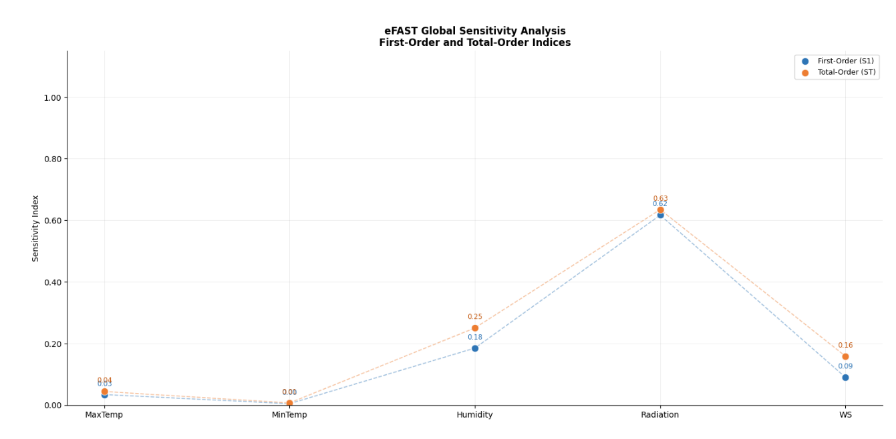
(a)
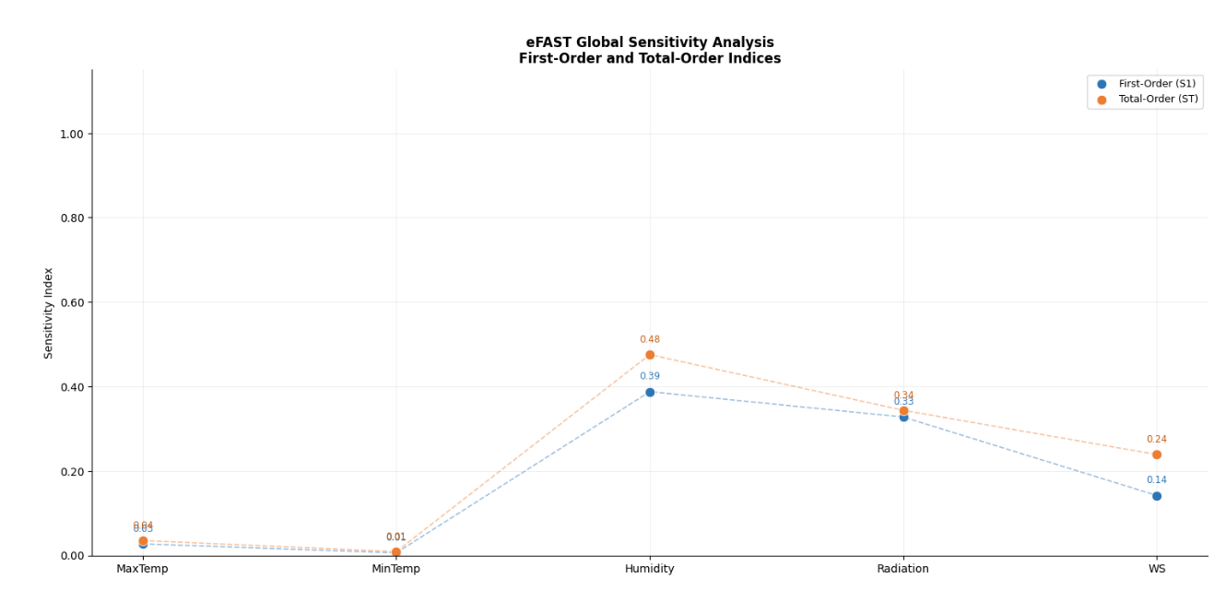
(b)
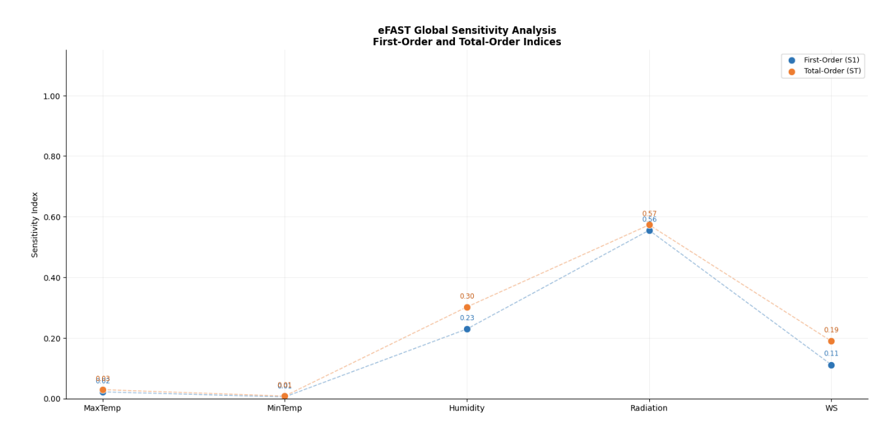
(c)
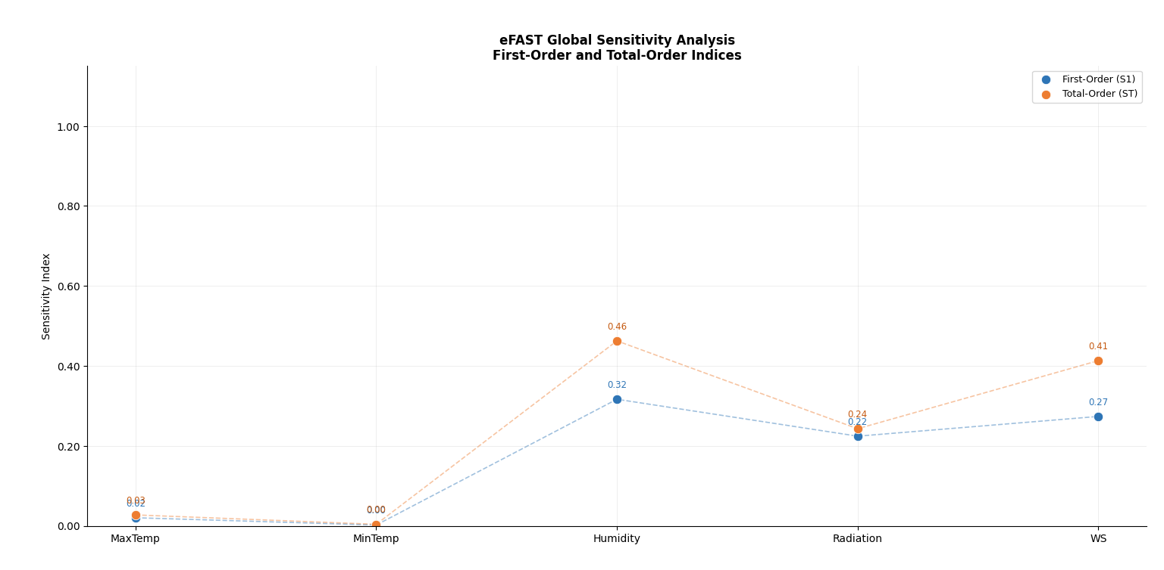
(d)
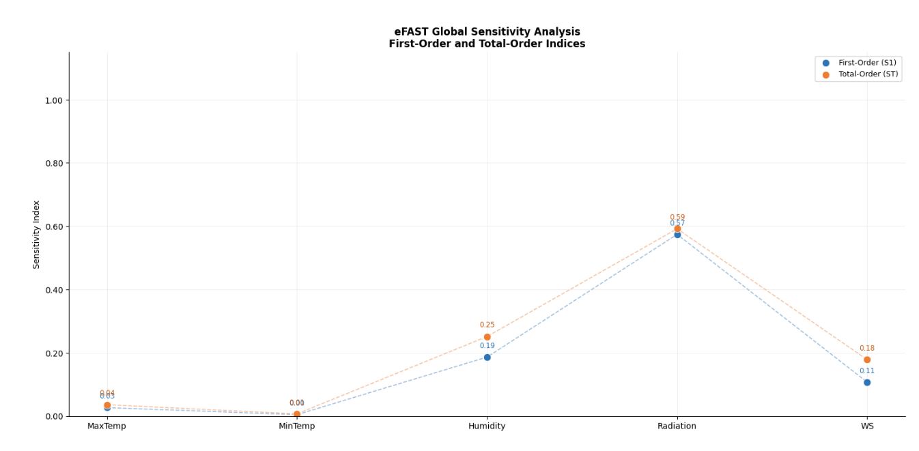
(e)
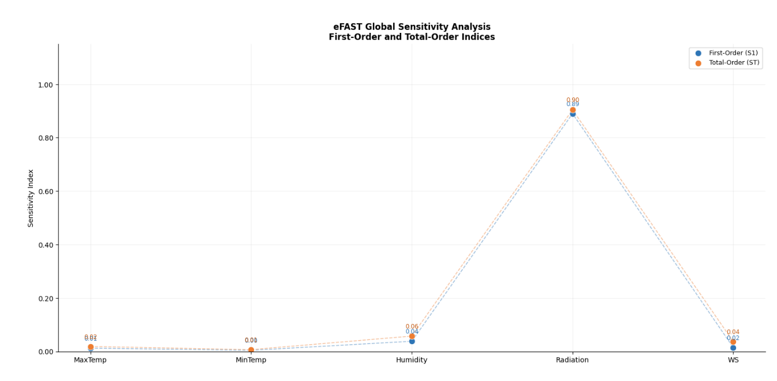
(f)
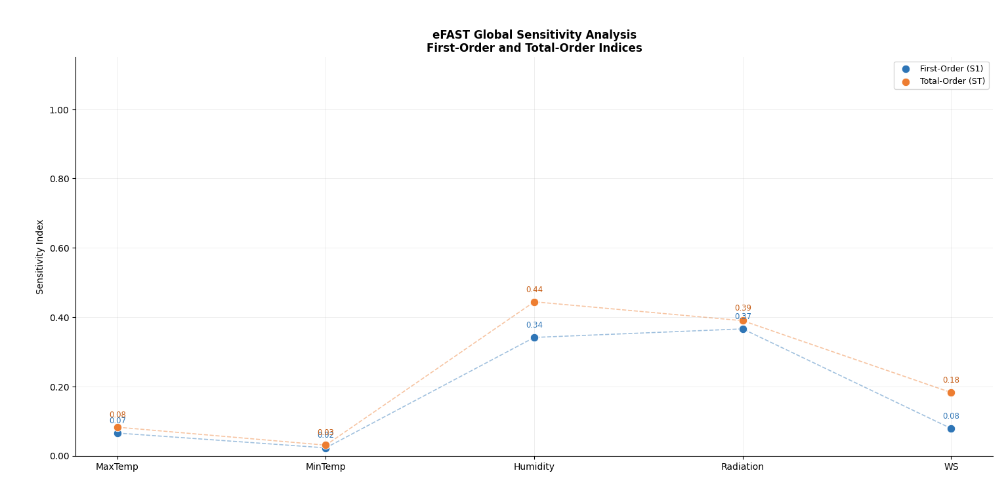
(g)
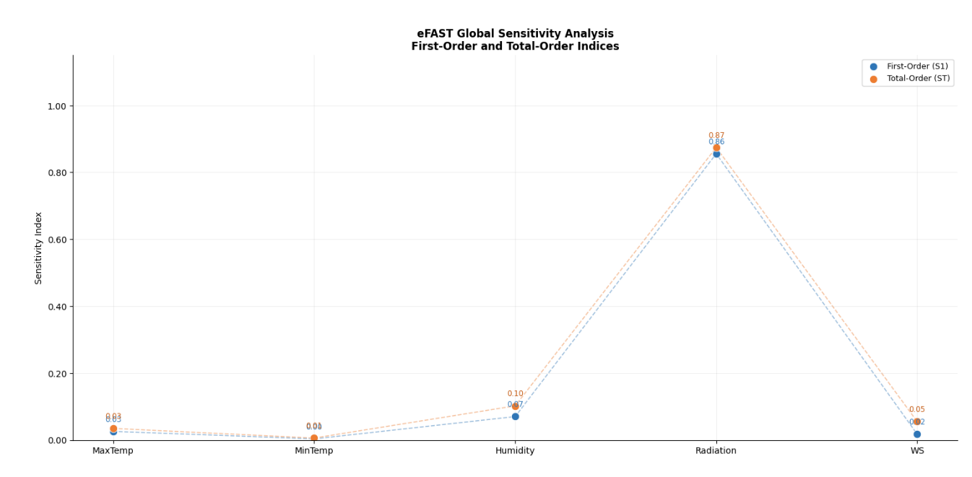
(h)
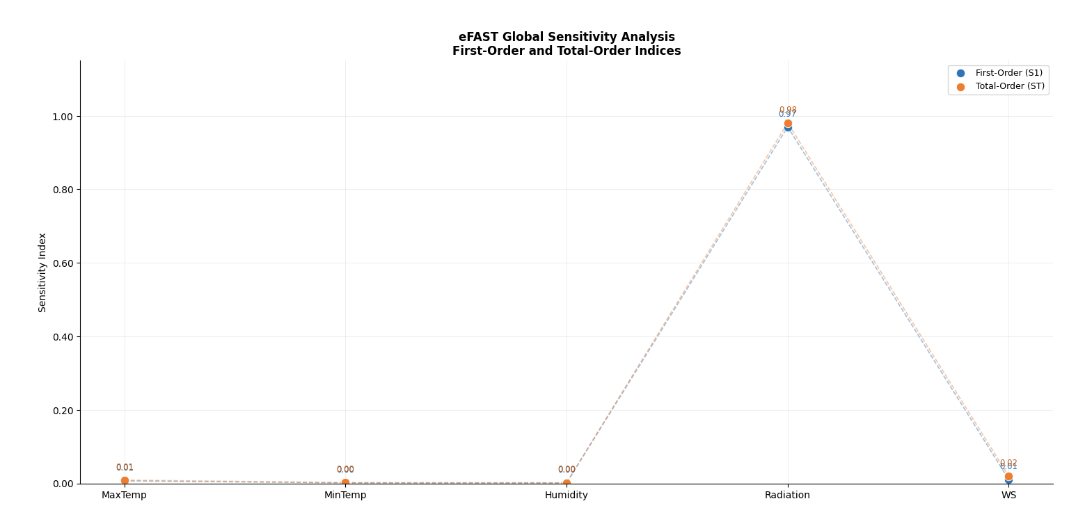
(i)
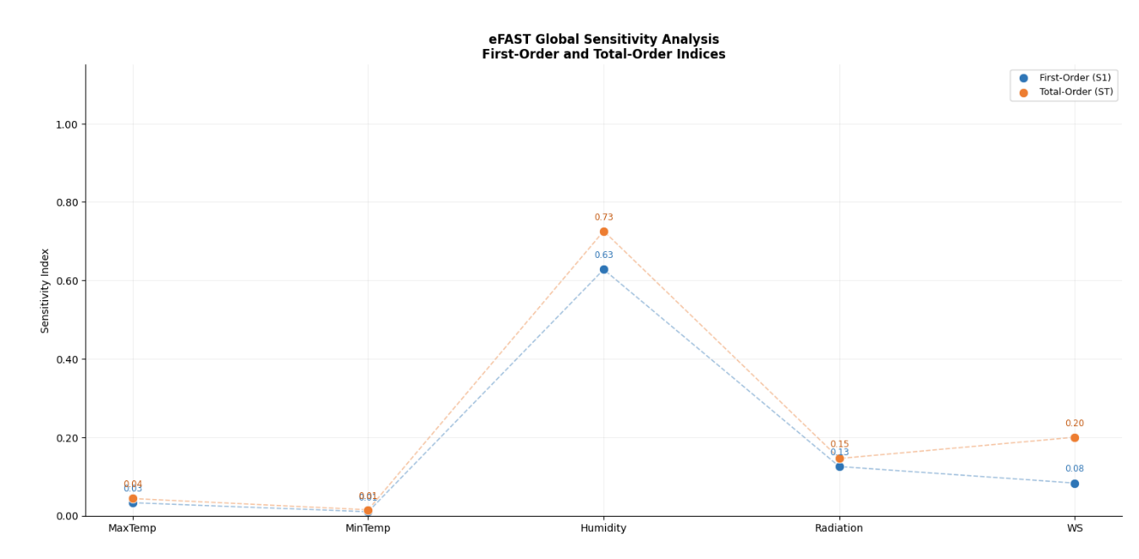
(j)
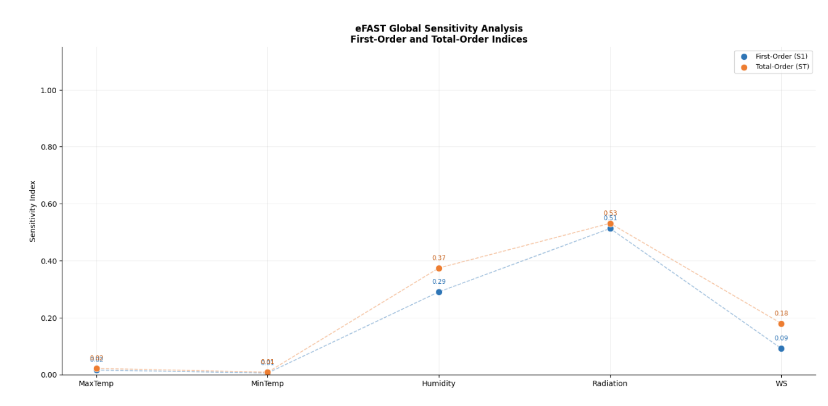
(k)
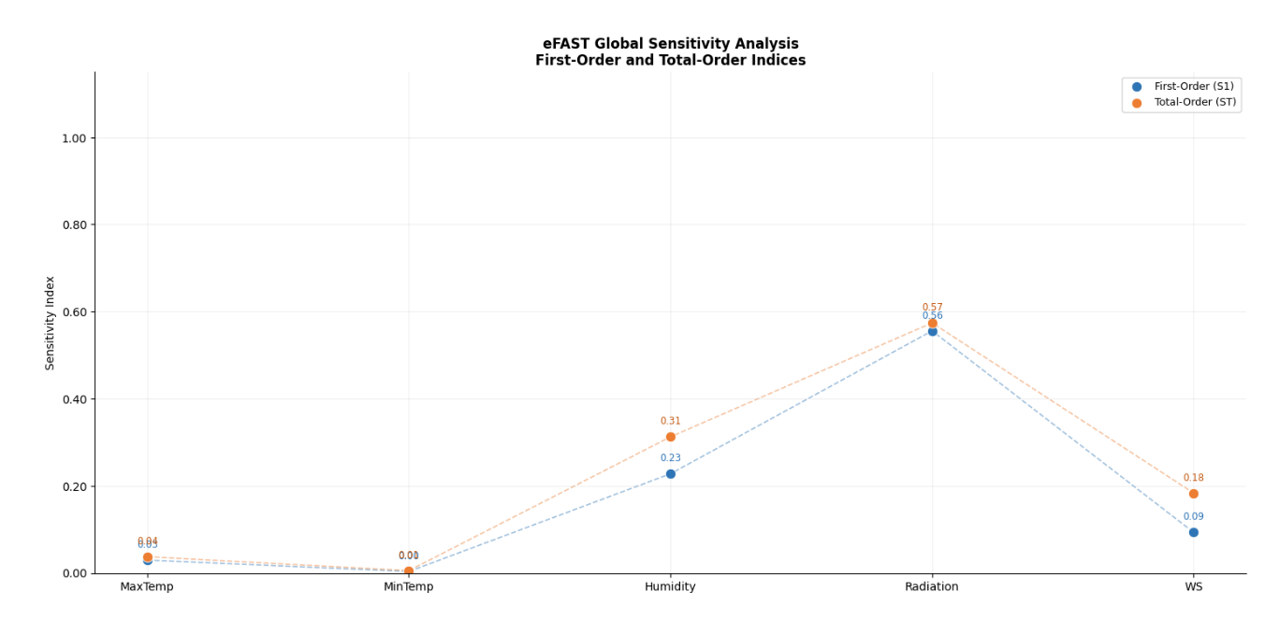
(l)
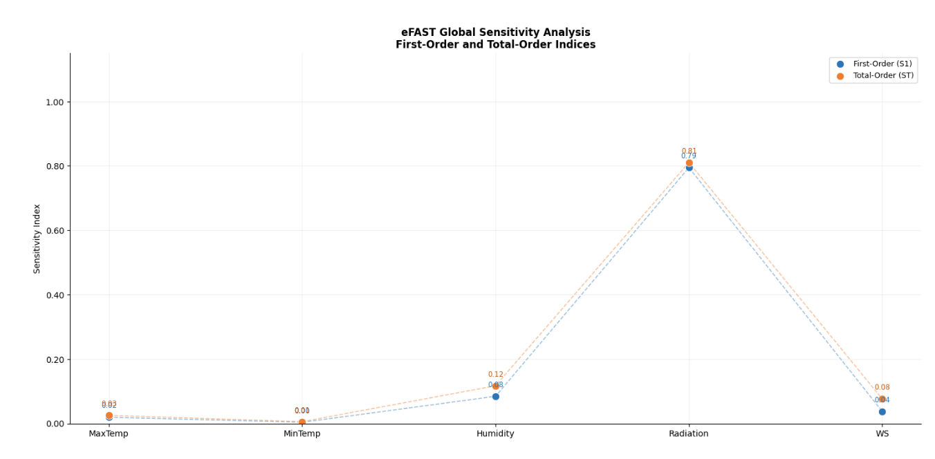
(m)
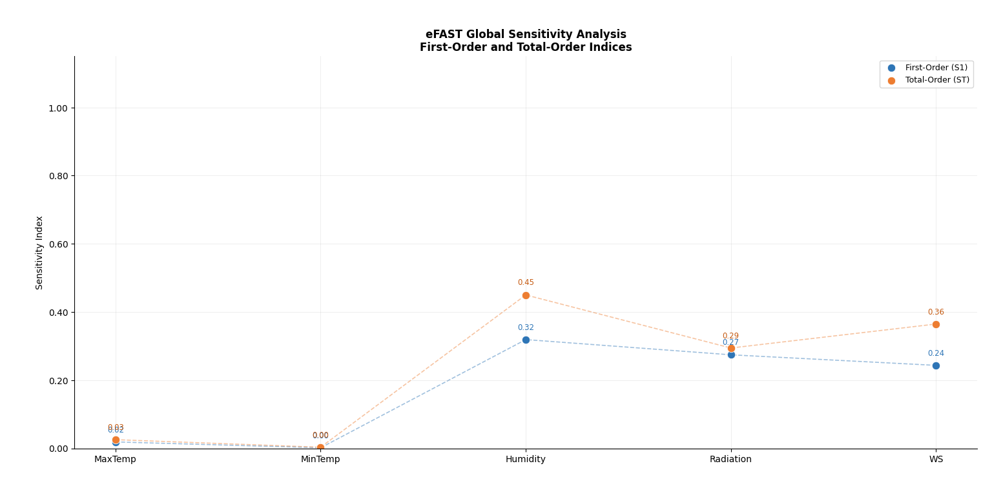
(n)
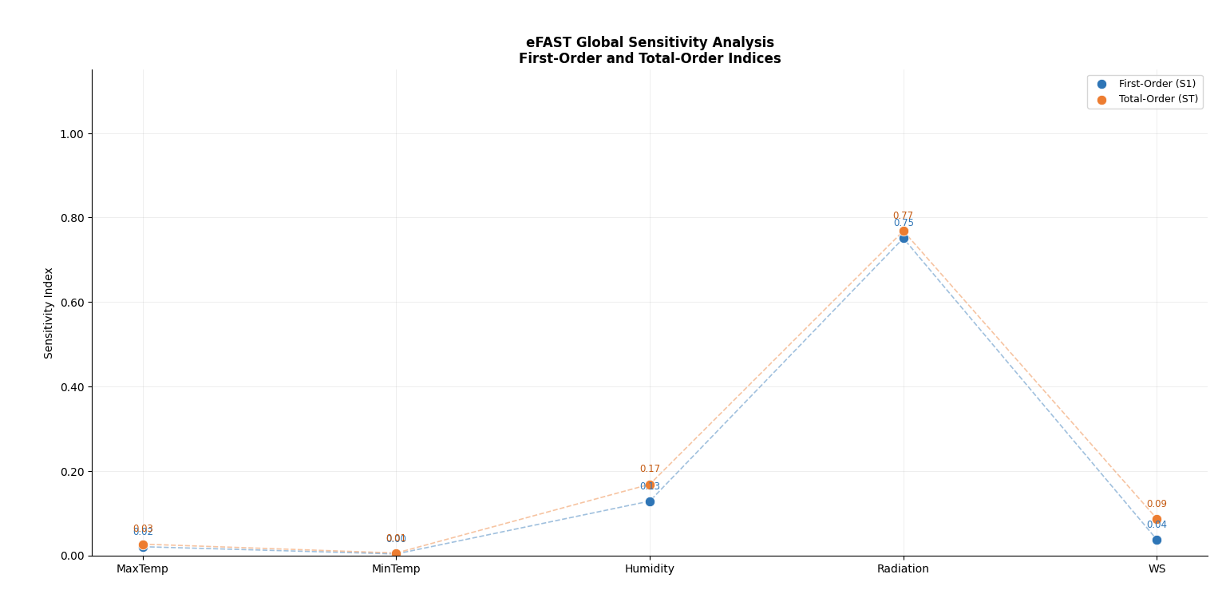
(o)
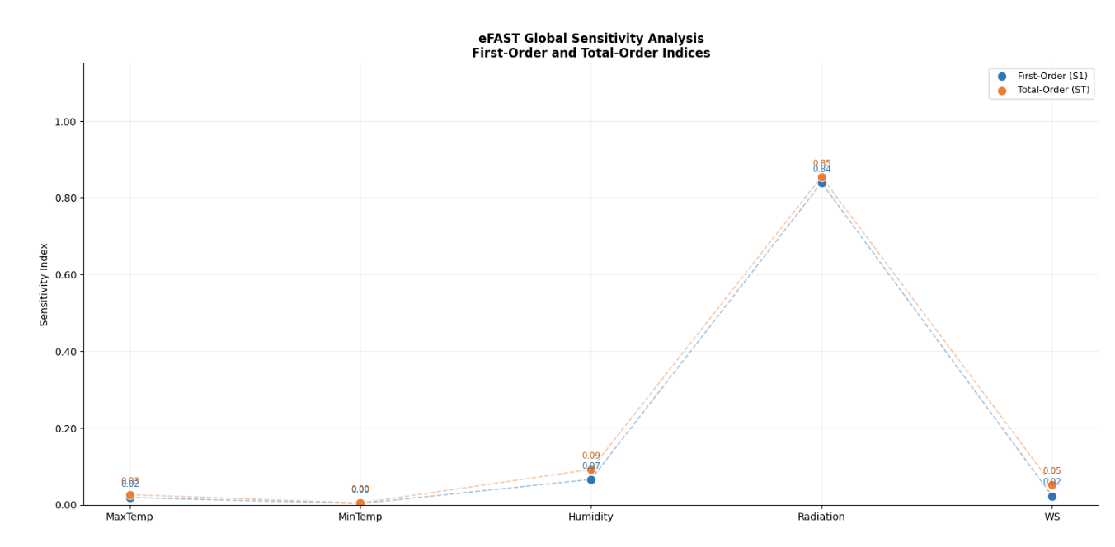
(p)
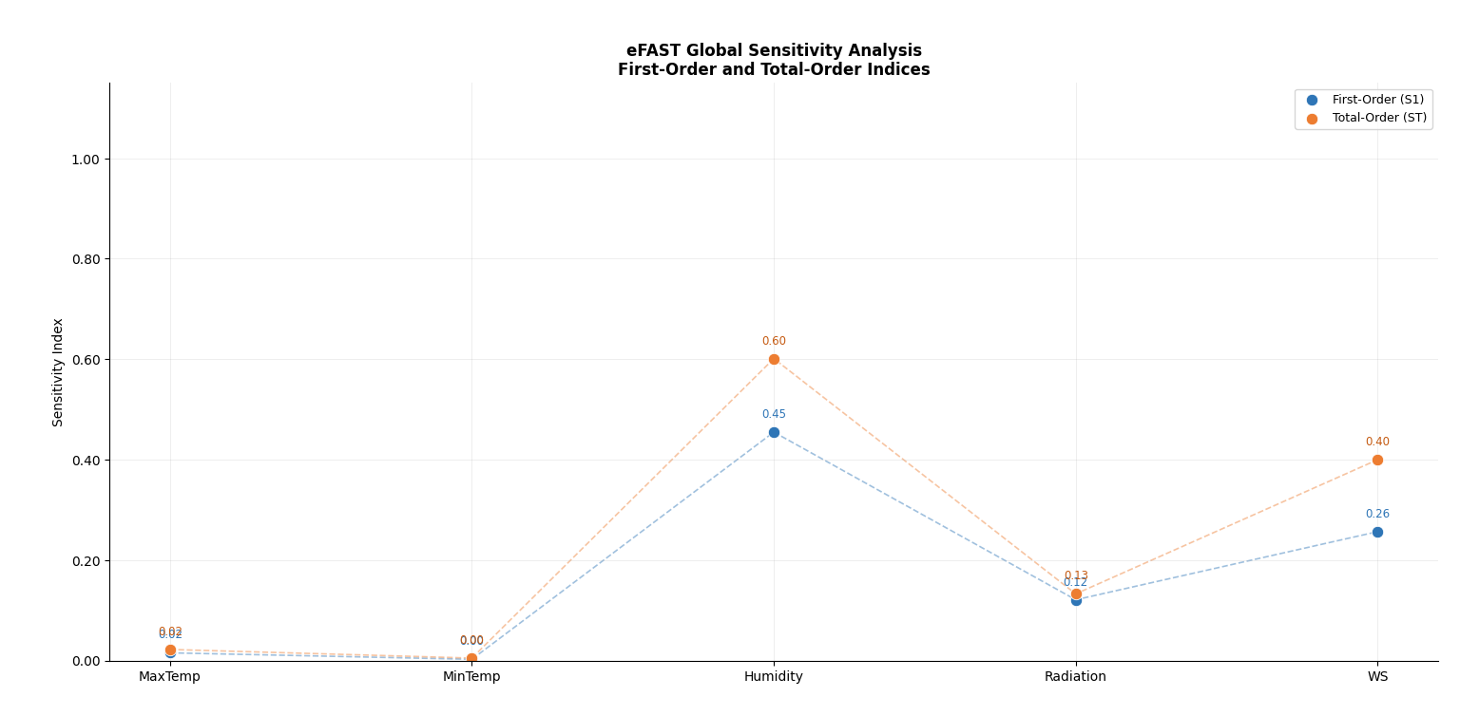
(q)
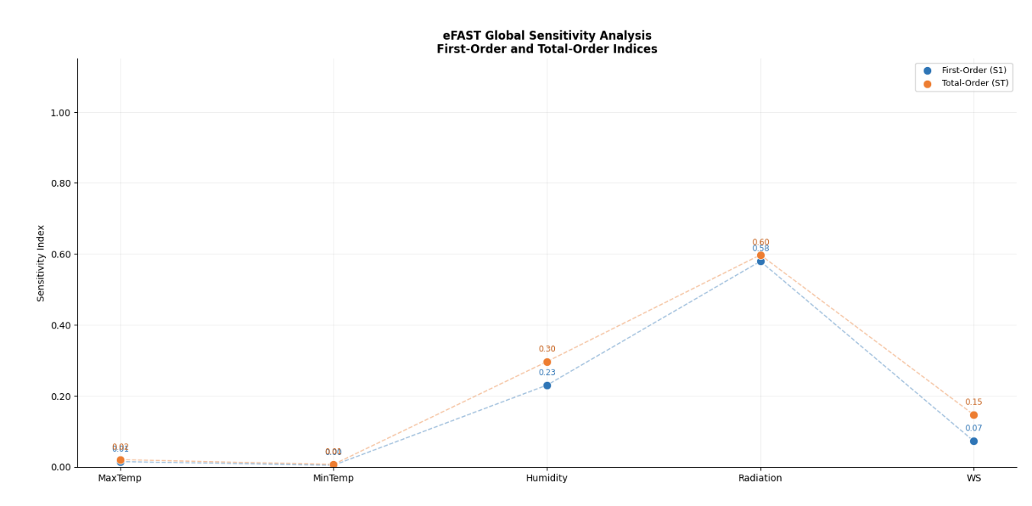
(r)
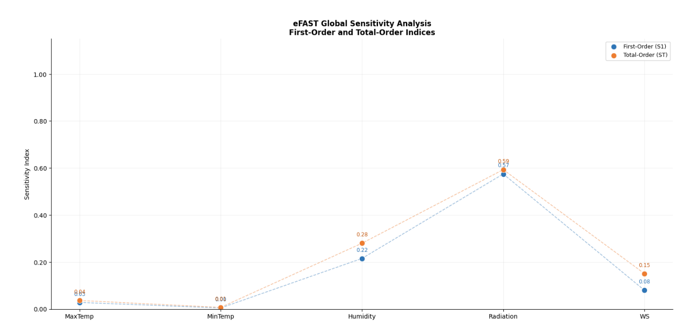
(s)
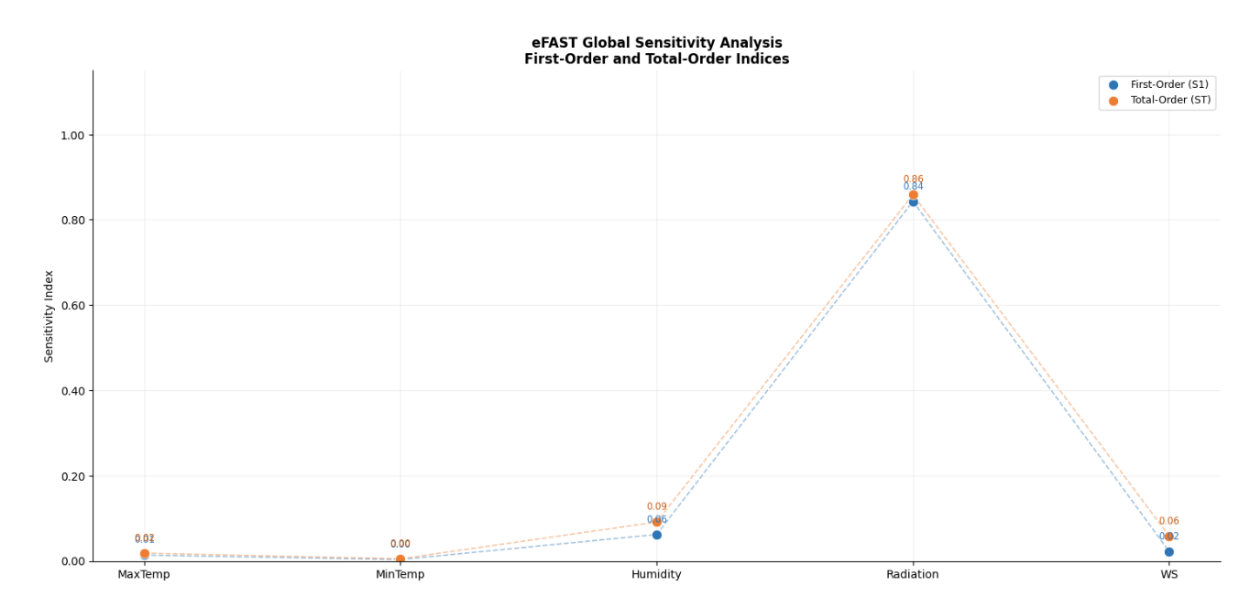
(t)

Fig. 4 Comparison of First-Order and Total-Order Sensitivity Indices for meteorological variables at the (a) Alor Setar, (b) Pulau Langkawi, (c) Bayan Lepas, (d) Ipoh, (e) Sitiawan, (f) Lubok Merbau, (g) Cameron Highlands, (h) Kuantan, (i) Muadzam Shah, (j) Kota Bahru, (k) Kuala Terengganu, (l) KLIA Sepang, (m) Subang, (n) Kuching, (o) Miri, (p) Sibu, (q) Sandakan, (r) Labuan, (s) Kota Kinabalu, (t) Tawau stations.

